DNS Checker:

<https://www.whatsmydns.net/#A/docker.trend-ai.tech>

<https://dnschecker.org/#A/docker.trend-ai.tech>

Hide "Powered By Odoo"

<https://youtu.be/QJGqQzxsohY?feature=shared>

[Website analytics — Odoo 17.0 documentation](https://www.odoo.com/documentation/17.0/applications/websites/website/reporting/analytics.html)

<https://www.odoo.com/documentation/17.0/applications/websites/website/reporting/analytics.html>

<https://plausible.io/register>

trenders.intl@gmail.com

Trend@PLBL2024

Google

<!-- Google tag (gtag.js) --> <script async src="https://www.googletagmanager.com/gtag/js?id=G-L979M2DYMC"></script> <script> window.dataLayer = window.dataLayer || []; function gtag(){dataLayer.push(arguments);} gtag('js', new Date()); gtag('config', 'G-L979M2DYMC'); </script>

<https://www.odoo.com/documentation/17.0/applications/websites/website/configuration/google_search_console.html?highlight=google%20search>

<https://search.google.com/search-console?resource_id=https%3A%2F%2Ftrend-ai.net%2F>

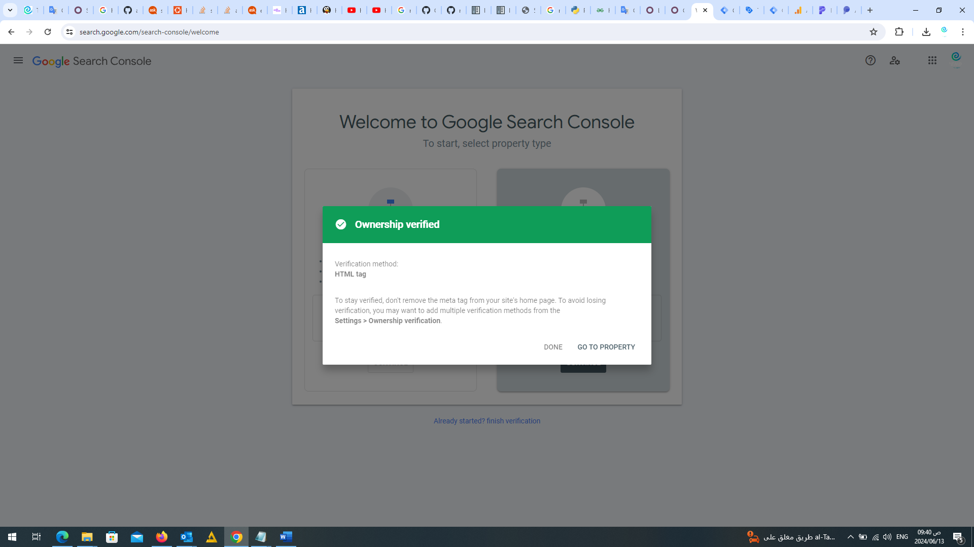

<https://search.google.com/search-console?resource_id=https%3A%2F%2Ftrend-ai.net%2F>

curl -s <https://raw.githubusercontent.com/pro-777//Hello-odoo15/master/run.sh> | sudo bash -s odoo-one 10015 20025

curl -s https://raw.githubusercontent.com/pro-777/Hello-odoo16/master/run.sh | sudo bash -s odoo-one 10016 20016

curl -s https://raw.githubusercontent.com/minhng92/odoo-17-docker-compose/master/run.sh | sudo bash -s odoo-one 10017 20017

#!/bin/bash

DESTINATION=$1

PORT=$2

CHAT=$3

# clone Odoo directory

git clone --depth=1 https://github.com/pro-777/Hello-odoo15.git $DESTINATION

rm -rf $DESTINATION/.git

# set permission

mkdir -p $DESTINATION/postgresql

sudo chmod -R 777 $DESTINATION

# config

if grep -qF "fs.inotify.max_user_watches" /etc/sysctl.conf; then echo $(grep -F "fs.inotify.max_user_watches" /etc/sysctl.conf); else echo "fs.inotify.max_user_watches = 524288" | sudo tee -a /etc/sysctl.conf; fi

sudo sysctl -p

sed -i 's/10015/'$PORT'/g' $DESTINATION/docker-compose.yml

sed -i 's/20015/'$CHAT'/g' $DESTINATION/docker-compose.yml

# run Odoo

docker-compose -f $DESTINATION/docker-compose.yml up -d

echo 'Started Odoo @ http://localhost:'$PORT' | Master Password: mostafa@1234 | Live chat port: '$CHAT